Report

Requirements Document

*2DV608*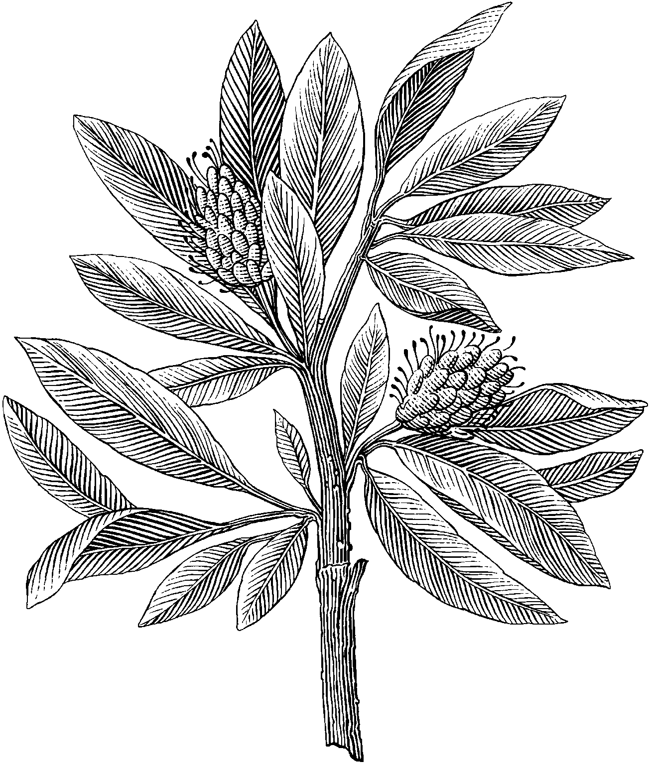

*Author:* Xingrong Zong

*Semester:* Spring 2021

*Email:* xz222bb@student.lnu.se

Contents

1 Introduction 1-2

1.1 Product 1-2

1.2 Scope of the product 1-2

1.3 Definitions, acronyms, and abbreviations 1-2

1.4 References 1-2

1.5 Overview of the remainder of the document 1-2

2 General description 2-3

2.1 Product perspective 2-3

2.2 Product functions 2-3

2.3 User characteristics 2-3

1.1.1 Discussion 2-3

2.4 General constraints 2-3

1.1.2 Discussion 2-3

2.5 Assumptions and dependencies 2-3

3 Specific functional, non-functional, and interface requirements 3-3

3.1 Discussion 3-4

4 Appendices 4-4

3.2 Discussion 4-4

5 Index 5-5

3.3 Discussion 5-5

# Introduction

Imagine designing and developing an online video streaming service.

Imagine designing and developing and online shopping portal.

Stakeholders: identify the complete list of stakeholders

Requirements: elicit and label three functional and three non-functional requirements (properly label requirements)

Requirements analysis: perform a systematic ‘checklist-based’ requirements analysis.

Requirements classification: classify the identified requirements using the ‘faceted approach’.

Risk assessment of requirements: systematically assess the risks of your requirements.

Systematic validation of requirements: perform a ‘systematic validation’ of the requirements.

Test cases for requirements: propose one test case for each requirement.

Requirements document: create a final ‘requirements document’ with the above 7 topics.

## Purpose of the requirements document

## Scope of the product

## Definitions, acronyms, and abbreviations

## References

## Overview of the remainder of the document

# General description



## Product perspective

## Product functions

## User characteristics

### Discussion

## General constraints

### Discussion

## Assumptions and dependencies

# Specific functional, non-functional, and interface requirements

Eg: external interfaces, functionality, performance requirements, logical database requirements, design constraints, system attributes, and quality characteristics



## Discussion

# Appendices



## Discussion

# Index



## Discussion